Project Design Phase-II
Technology Stack (Architecture s Stack)

Date | 20 February 2026
Team ID | LTVIP2026TMIDS79334
Project Name | Empowering India: Analysing the Evolution of Union Budget Allocations for  Sustainable Growth
Maximum  Marks | 4 Marks
Technical Architecture:
The Deliverable shall include the architectural diagram as below and the information as per the table1 C table 2

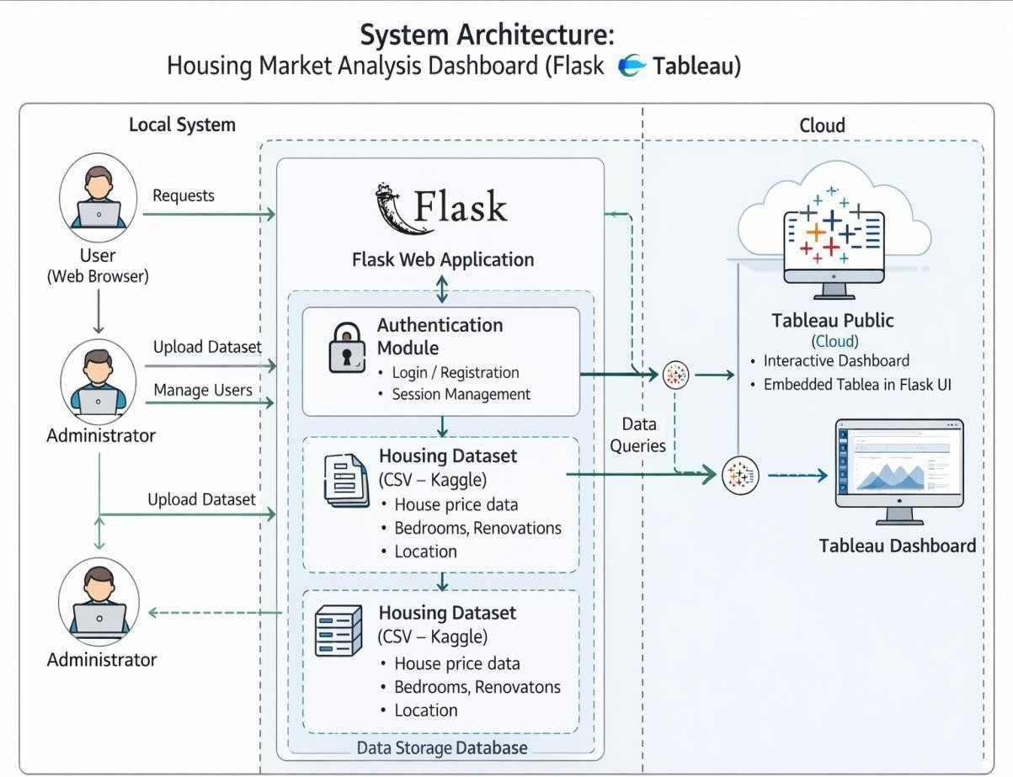
S.No | Component | Description | Technology
1 | User Interface | Web UI where user logs in and views dashboard | HTML, CSS, Bootstrap
2 | Application Logic-1 | Handles login, routing and request processing | Python (Flask)
3 | Application Logic-2 | Data filtering and processing logic | Python (Pandas)
4 | Application Logic-3 | Embedding and displaying  Tableau dashboard | Tableau Public (Embed  Code)
5 | Database | Stores user login details | SQLite
6 | Cloud Database | Not used in this project | Not Applicable
7 | File Storage | Stores housing dataset CSV file | Local File System
8 | External API-1 | Interactive dashboard  visualization service | Tableau Public
9 | External API-2 | Gmail login (if implemented) | Google OAuth API
10 | Machine Learning  Model | Not used in this system | Not Applicable
11 | Infrastructure  (Server / Cloud) | Application runs locally and connects to Tableau Cloud | Local Server (Flask) +  Tableau Public

Table-2: Application Characteristics:

S.No | Characteristics | Description | Technology
1 | Open-Source  Frameworks | Backend framework used for development | Flask (Python)
2 | Security  Implementations | Secure login, password hashing, session control | Flask Session,  Werkzeug Security
3 | Scalable Architecture | Modular design allowing future data expansion | Flask Architecture
4 | Availability | Accessible when server is running | Local Server / Cloud  Hosting
5 | Performance | Fast dashboard loading and efficient filtering | Pandas + Tableau  Rendering

References:
https://c4model.com/ https://developer.ibm.com/patterns/online-order-processingsystem-during-pandemic/ https://www.ibm.com/cloud/architecture https://aws.amazon.com/architecture
https://medium.com/the-internal-startup/how-to-draw-useful-technical-
architecture- diagrams-2d20cGfdaG0d

